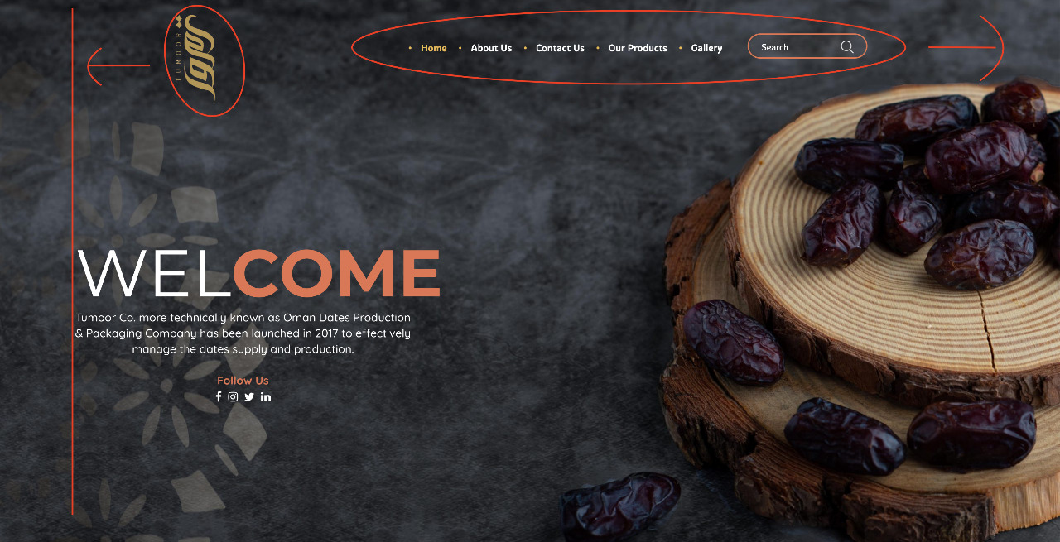

1. logo to be moved, to align with the below text
2. Navbar(menu items to be moved to the right a bit). Please check in bigger screen also how it behaves, Navbar to be scrolling all over

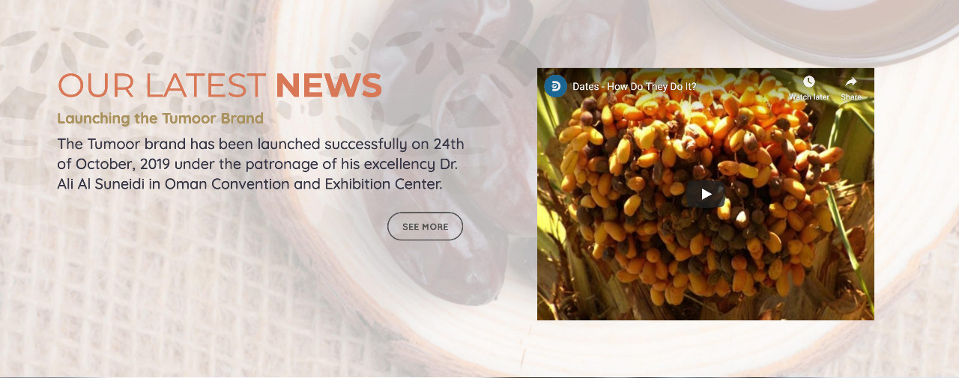

1. background will be replaced with new one, will share this later on

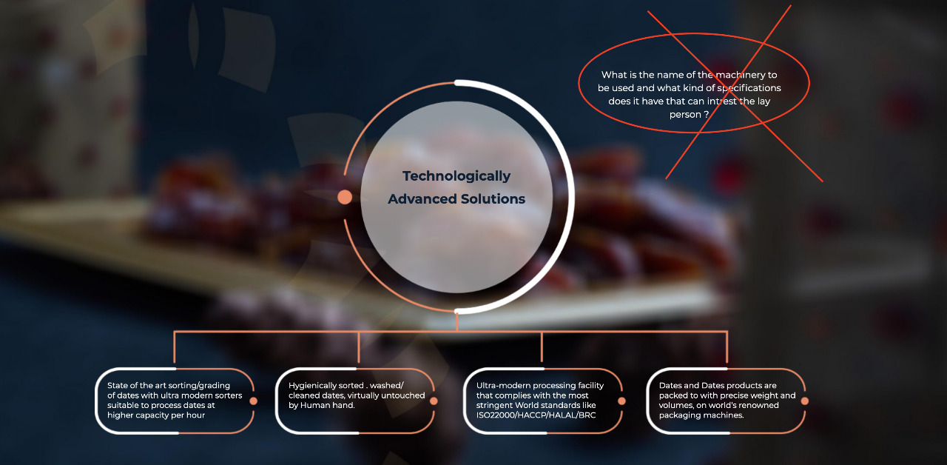

1. Text with the cross mark (X) to be removed
2. Those circles and rectangles should have some sort of animation, check the below links.

<https://www.kirupa.com/animations/creating_pulsing_circle_animation.htm>

<https://codepen.io/bhaveshgohel/pen/mdEwK>

<https://codepen.io/savant/pen/idbAh>

1. Note that, mobile version can be only loading with simple effect to reduce difficulties of implementation.

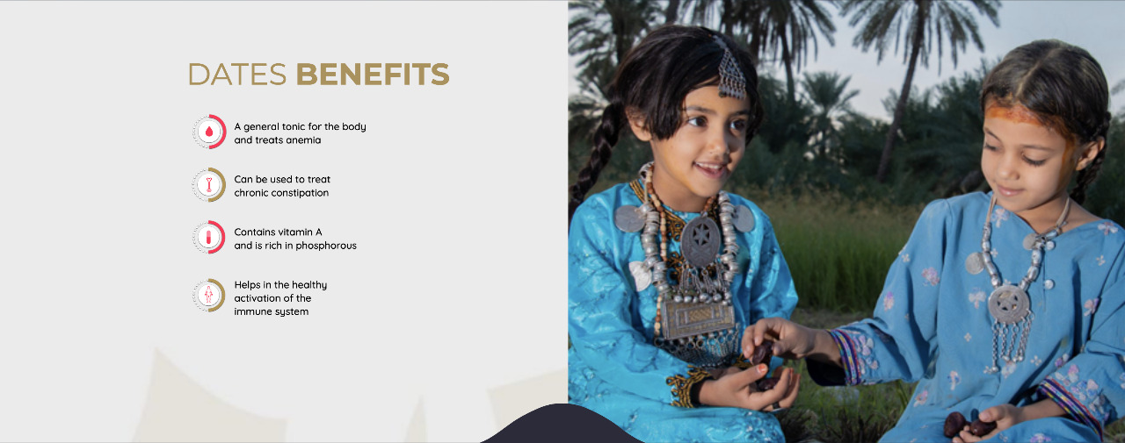

1. -This section will be re-produced with new design, simpler one.

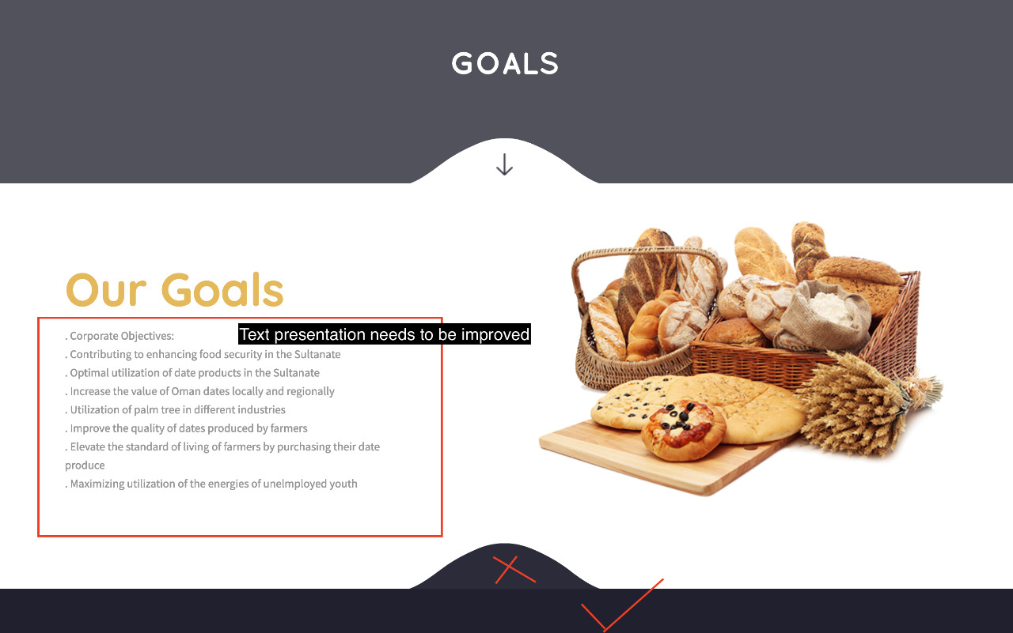

1. -footer is having to different colors
2. -Text presentation need to be improved

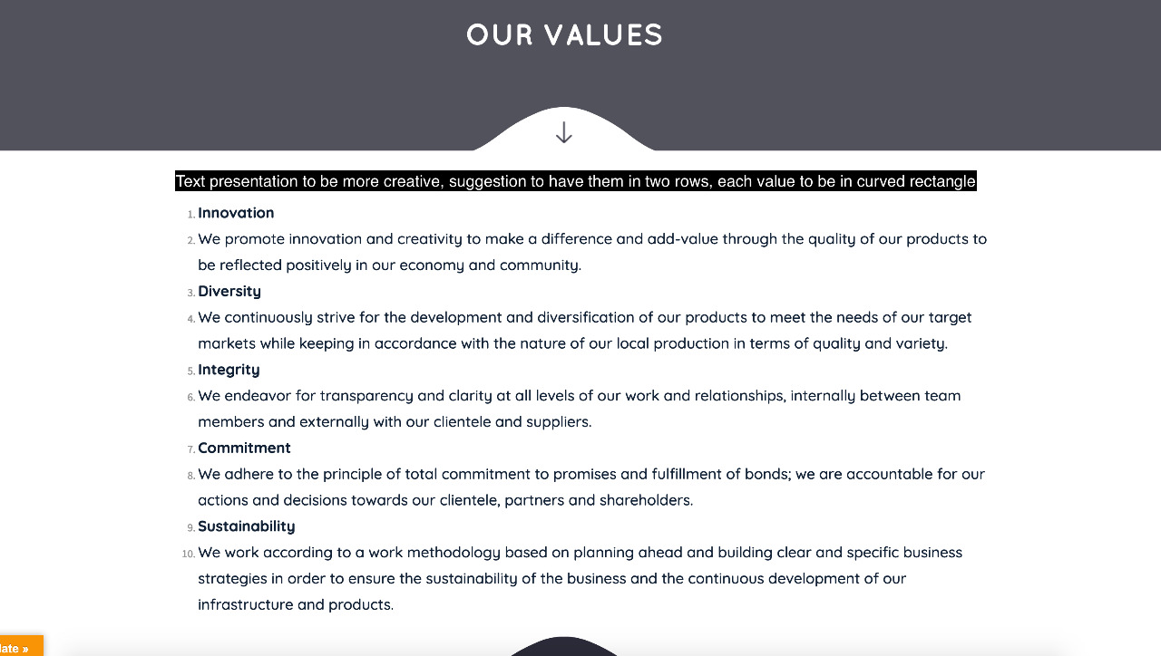

1. -Change text presentation to be more creative

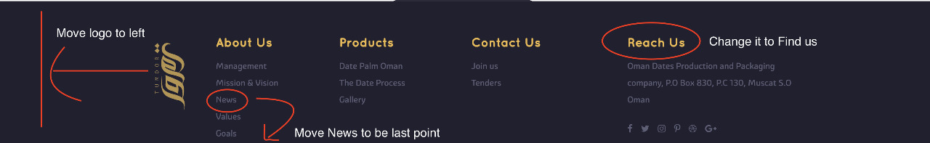

1. -Move logo to left
2. -New to be kept as last option under about us
3. -Reach us to be change to “Find us”

